**Topcoder Member Service - New Endpoint to Update Email Address Code Challenge v1.0**

**Verification Guide**

# 

# Setup

Following the LocalSetup.docx to setup the enironments.

For the event bus mock service, nodejs 4+ is required. Enter eventBusMock, run 'npm i' and 'npm start' to run the mock event bus. In eventBusMock/src/config.js, you can change the port from 8087 from other ones if it's already used.

After start, the console will look like:

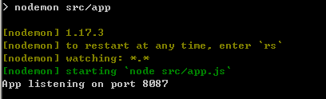

Go to ap-member-microservice-dev/local/aws-cli, run the following command to insert the data for the user heffan:

aws dynamodb batch-write-item --request-items file://heffan.json --endpoint-url http://$IP:7777

If the port of the eventBusMock is changed, you should update the port in the ap-member-microservice-dev/service\src/main/resources/member-service.yaml

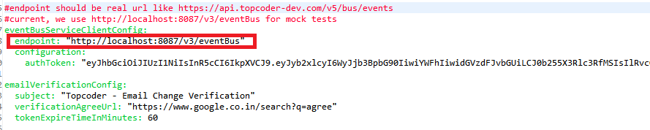

Open command line terminal, in ap-member-microservice/service

$mvn clean compile package -DskipTests

$java -jar target/member-microservice-*.jar server src/main/resources/member-service.yaml

Then enter to the ap-member-microservice-dev/local/aws-cli, run the following command to insert the data for the user heffan(please check LocalSetup.docx for the environment setup):

aws dynamodb batch-write-item --request-items file://heffan.json --endpoint-url http://$IP:7777

# Verify

Import the docs/postman/Member Service.postman_collection.json to the postman.

Member Service.postman_environment.json should also be imported as environment.

Click the Memeber Profile sub folder

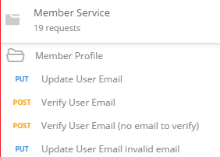

Update User Email

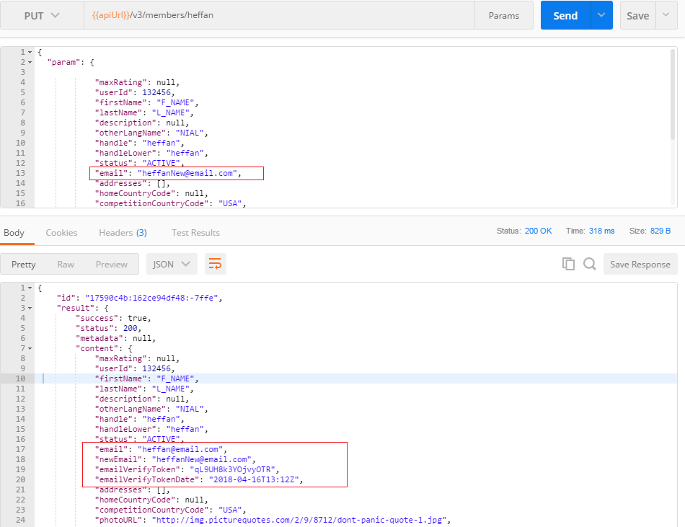

Then check the console of the mock event bus, it should receive the json data:

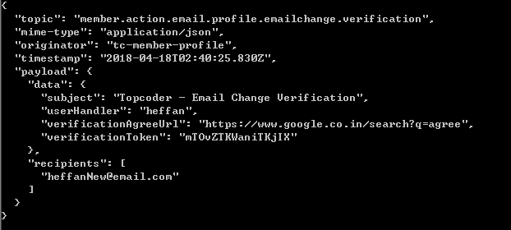

Then check the database.

enter to the ap-member-microservice-dev/local/aws-cli, run the following command:

aws dynamodb query --table-name MemberProfile --select ALL_ATTRIBUTES --key-condition-expression "userId = :userId" --expression-attribute-values '{":userId": {"N": "132456"}}' --endpoint-url http://$IP:7777

The token, new email, etc should be stored.

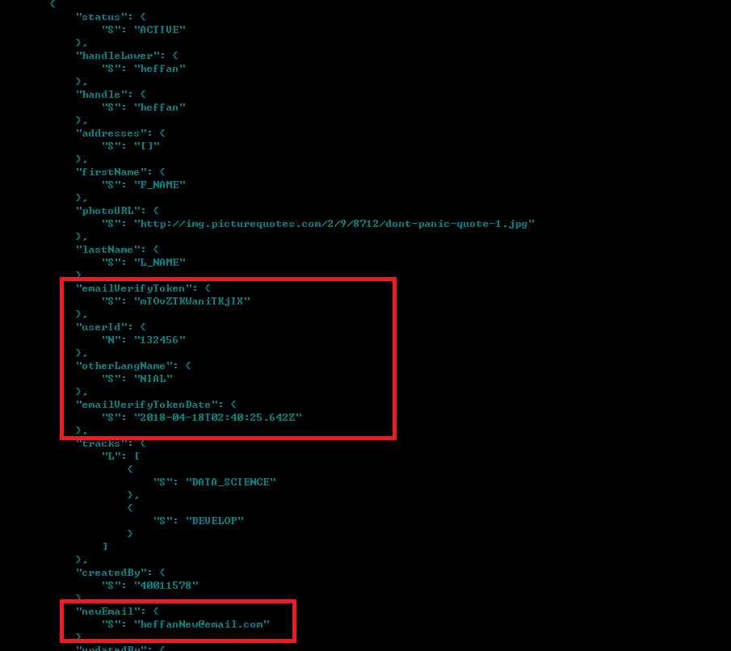

Verify User Email

The oldEmail and newEmail should be set correctly. The token should also be retrieved from the response of the 'Update User Email'

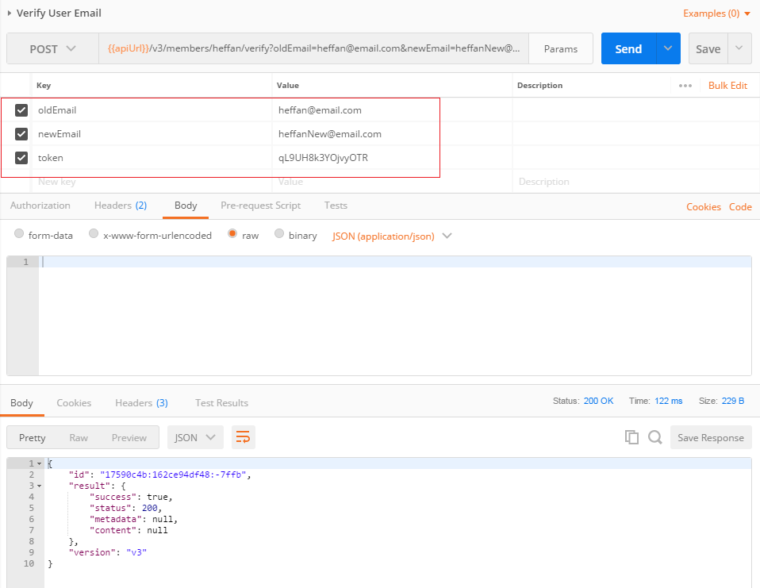

Then check the database.

enter to the ap-member-microservice-dev/local/aws-cli, run the following command:

aws dynamodb query --table-name MemberProfile --select ALL_ATTRIBUTES --key-condition-expression "userId = :userId" --expression-attribute-values '{":userId": {"N": "132456"}}' --endpoint-url http://$IP:7777

You can check that the newEmail, token and token date is set to null in the database, and the email field is update with the new email.

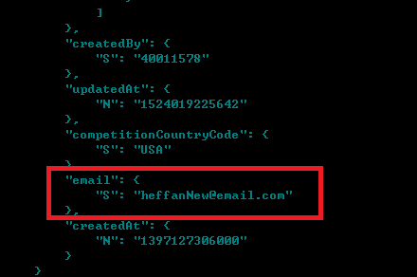

You can also check ' Get member profile' to check the profile data:

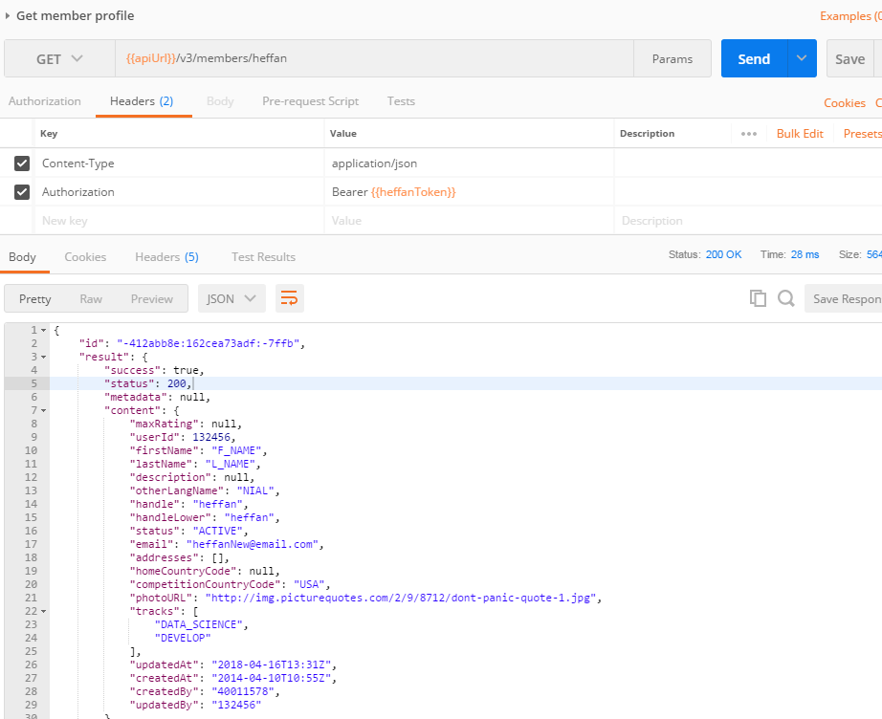.

If the token is not specified correctly, the error will be:

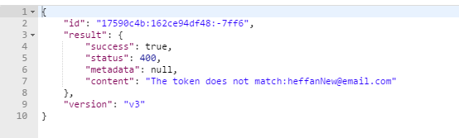

For the other invalid cases, check them similar.